

|  |  |
| --- | --- |
| Operation: | Urgent Fury |
| Episode: | #1 Rebuilding |
| Location: | Anizay |
| Date: | 23/11-2005 |
| Time: | 07:00 |
| Password: | LRGOps |

|  |
| --- |
|  |
| We are LRG deployed to an airfield in Anizay to help the US forces after one of their FOB were under artillery fire and a convoy were ambushed by the local insurgents. |

|  |
| --- |
|  |
| Mission Critical Objective:   * Clear the town of Kahs * Check out ambush Point * Clear the town of Anizay * Secure FOB Obeh * Supply FOB Obeh with construction materials * Find Arty guns   Secondary Objectives:   * Clear main convoy route of IED`s * Find and destroy ammo/IED stashs * conduct a raid on IED maker compound |

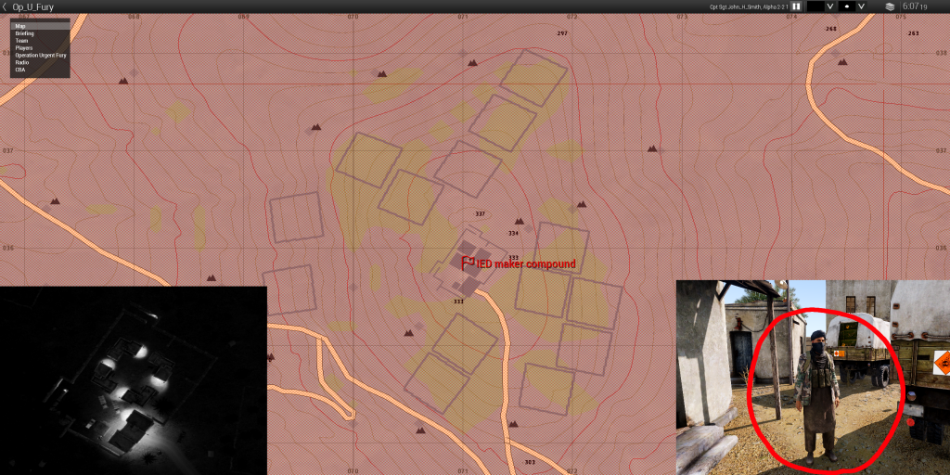

|  |  |
| --- | --- |
| **Air Assets** | |
| 3x UH-60M | 3x UH-60M MEV |
| 4x Darter | 2x MQ-9 Reaper |
| **Ground Assets** | |
| 3x MAN HX58 | 3x Husky Logistics GPMG |
| 4x Husky Passenger HMG | 4x Husky Passenger GPMG |
| **Available Support Teams** | |
| Recce | Sniper Team |
| Logistical Team |  |
|  |  |

|  |
| --- |
|  |
| * Try to protect the civilian population and minimize damage to the infrastructure and buildings. |